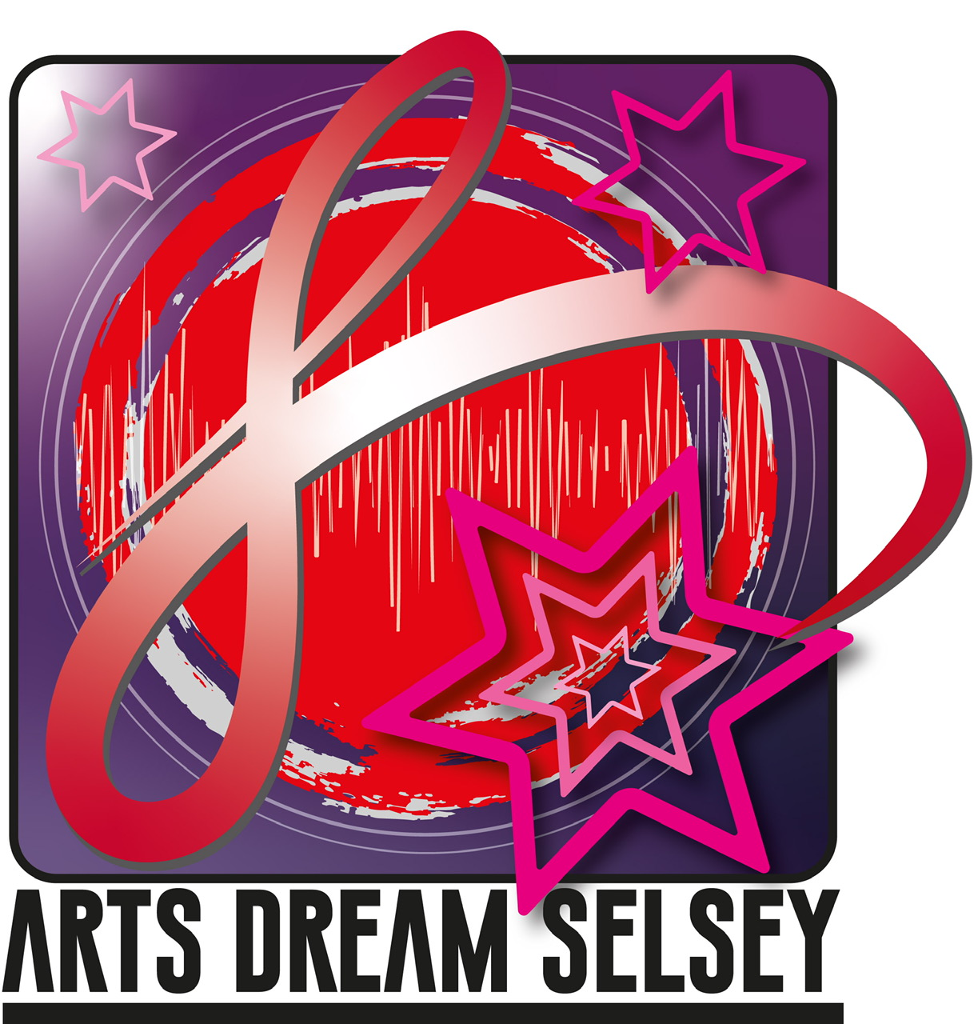
Arts Dream Selsey (ADS) Covid statement

Introduction:

Arts and culture can illuminate our inner lives and enrich our emotional world and have a wider more measurable impact on our economy, health, and wellbeing. ADS is keen on welcoming our users back to restart activities. We know this has been a difficult time for everyone, but we are keen to continue with creative live indoor activities and events in line with Government Guidelines.

Statement from ADS:

ADS is hoping to start activities from September 2021 and to pilot art, drama and singing activities
- Our aim is to keep all our users, audiences, performers, and crew as safe as possible and to limit any possible chance of transmission of the virus.
- We will take account of the necessary guidance from GOV.UK on working safely in the arts, and for guidance for the safe use of multi -purpose community facilities.
- At this time no refreshment, drinks etc will be offered for sale, but users can bring their own individual refreshments.

What you can expect from us:

- Comprehensive Covid Risk Assessments for all activities. These will be published on our website and on our Face Book page
- Specific protocols in place regarding Front of House Procedures for users and staff
- Specific rehearsal strategies in place to minimise transmission and comply with social distancing
- An extensive cleaning regime in place for all activities, at a variety of different venues.
- New guidance on how to obtain tickets for events, to comply with social distancing and the specific requirements of different venues.
- Volunteers and our trustees trained to be effective in the delivery of Health and Safety requirements
- Volunteers to wear PPE as appropriate
- Compliance with the Risk Assessments of different venues.

What we expect from our users:

- Not to attend any classes or performances if you are feeling unwell or have any Covid symptoms.
- To use the hand sanitizer that is provided
- To comply with the social distancing guidelines and other signage around the venue
- To wear masks as appropriate during classes and performances
- To follow floor markings where necessary
- To allow us to keep your contact details to track and trace if necessary

Arts Dream Selsey (ADS) Covid Risk Assessment for all performance events:

Introduction:

COVID-19 is a disease which is caused by the SARS-CoV-2 virus, which can be passed via respiratory secretions (i.e., saliva) and faeces, and which can successfully live for up to 2 to 3 days on certain
surfaces. COVID-19 is an “enveloped” virus, meaning that it is surrounded by a protective layer of fats and proteins.
COVID-19 can be transferred via hands from one surface to another. By touching a surface which has traces of COVID-19 on it, and then touching your face or eyes, you may become infected with COVID-19.
Soap and hand sanitiser are effective at denaturing the fats and proteins surrounding the virus, and therefore good ways to kill the virus.
COVID-19 can live on some common household surfaces for up to 3 days. Information and
knowledge is evolving all the time. Currently it is thought that the virus can live for up to:
● 2-3 hours in the air
● Up to 4 hours on copper
● Up to 24 hours on cardboard, glass, and metal.
● Up to 2 or 3 days on plastic and stainless steel.

General Principles:

This General risk assessment is developed in conjunction with other ADS risk assessments that are specific to a particular named performance or event and deals with the principles and process in regard to providing a safe environment for performers and audiences.
It can be applied to a number of venues, although we acknowledge that some venues, and community spaces will need for example additional cleaning, additional space arrangements, and a more robust adherence to rehearsal. ADS will put in place any measures or adjustments we see fit to comply with the necessary guidance.

The following Risk Assessment has been complied with details, information, and suggestions from:
- Gov.UK- Guidance and support for the safe use of multi -purpose community facilities
- Gov.UK- Working safely during coronavirus. – specifics on performing arts
- Arts Council England. – advise to venues.
- DCMS – Covid Guidelines
- Arts Professional – Covid toolkit
- Nesta- Creativity and Culture
- PASC-The Professional Association of self -Catering, protocols for Cleaning
- CDC Covid advise to businesses.
- ABCD guidance for Choral and Conductor activities

ARTS DREAM SELSEY COVID RISK ASSESSMENT (September- December 2021)

User Group:  Arts Dream Selsey .................................. | Nature of performance:  Selsey Community Choir .................................. | Venue:  The Methodist Hall Selsey
Risk assessment completed by:-  ...Chris Butler .................................. | Contact phone no:  ...01243606740.................................. | Email address:  chrisbutlerselsey@hotmail.co.uk...................................

RISK ASSESSMENT KEY
Severity | Likelihood | Risk rating
What is the potential level of injury to persons and / or damage to property caused by the hazard? | How likely is the hazard to happen? | Risk rating = Severity x Likelihood
- Slight  - Minor  - Moderate  - Major  - Severe | - Highly unlikely  - Not very likely  - Possible  - Likely  - Very likely

- To ensure preparation procedures for music activities limits the possibility of transmission
Description of activity / as- sociated risks | Who could be affected | Severity 1 to 5 | Likelihood 1 to 5 | Risk rating | Control measures  / Action plan
Lack of robust approach to preparation to front of house requirements may result in risk of transmission | Singers, their families, and wider contacts  Administration team | 1 | 1 | 1 | - Prior to the workshop ADS will have all track and trace information  - ADS to install necessary signage wherever necessary  - All procedures to be articulated on the ADS website, our face book page and through our mailing list  - The number of administration staff will be limited, and they will be advised to wear masks and visas  - Everyone to use hand sanitizer before and after they enter and leave the venue  - Track and trace lists will be kept, to include, name and phone number of all singers, administration team, choral and workshop leaders  - Singers asked to stagger arrival to the venue  - Attendance is conditional on being symptom free and in good health  - We would expect most participants to be double jabbed. This can be discussed with the administrative team  - Payment for sessions will be through SUMUP, bank transfer, or exact money in envelopes  - There will be no refreshments available all singers to bring their own

- To ensure social distancing is possible by limiting the number of people for musical activity to minimize transmission
Description of activity / as- sociated risks | Who could be affected |  | Severity 1 to 5 | Likelihood 1 to 5 |  | Risk rating |  | Control measures  / Action plan
Large numbers of singers increase risk  Too much movement around the venue causes risk  Failure to understand that the activity is about ‘singing’and is not a social activity  staff increases risk | Singers, admin staff and choral and workshop leaders |  | 1 | 1 |  | 1 |  | - Limit workshop numbers to ensuring social distancing can be operated within the required space of the venue  - Once people are in their allotted space they are advised not to move around the venue  - Provide clear advice to individuals regarding the specific nature of the activity  - Providing a clear communication strategy through the use of signage for entering and leaving the building  - Activity will be in a large well- ventilated room, all socially distanced, and will be time limited.  - Admin staff to be used to navigate singers in and out of the space  - Toilets will be operational throughout the workshop  - Participants to wear masks entering, leaving, and moving around the building
- To ensure cleanliness of venue, and all equipment limits the possibility of transmission
Description of activity / as- sociated risks |  | Who could be affected | Severity 1 to 5 |  | Likelihood 1 to 5 |  | Risk rating |  | Control measures  / Action plan
Lack of insufficient cleaning puts  people in undue risk of transmission  Contaminates surfaces causes risk, to include musical instruments |  | Singers, workshop leaders, admin staff | 1 |  | 1 |  | 1 |  | - ADS to purchase cleaning products, to include, spray virucidal disinfectant, gloves, cloths and masks, soap, hand sanitizer and paper towels  - More time be given between and after workshop to ensure deep cleaning  - All cleaners (volunteers) to wear masks, disposable gloves.  - Thorough cleaning will include wiping down of surfaces, tables, chairs, door handles and technical equipment, to include for example, music stands, musical instruments  - All windows to be opened during cleaning and the room to be well ventilated  - All cleaners advised to wash hands thoroughly after cleaning.

- To ensure the activity of singing is limited sufficiently to limit the risk of infection.
Description of activity / as- sociated risks | Who could be affected | Severity 1 to 5 | Likelihood 1 to 5 | Risk rating | Control measures  / Action plan

There is too much shouting,  talking and singing loudly that may increase air borne particles being transmitted  Choral and workshop leaders are too demonstrative whilst teaching | Singers, choral and workshop leaders, and admin staff | 1 | 1 | 1 | - If possible, all participants to be double jabbed  - Voices should not be raised in any way  - Doors and windows to be opened to allow for air flow through the building  - Configure singers in lines, avoiding singers being in front of one another  - Avoid singers facing each other  - No air conditioning systems to be on that can recirculate air.  - Be clear regarding Covid staff development for Choral and workshop leaders to ensure they are aware of the necessary guidelines  - Choral and workshop leaders should remain within a designated boundary  - If necessary, mark out spaces for leaders to operate within  - If musical scores are required, singers to bring their own.  - There will be no sharing of scores and no distribution of scores during the activity  - All singers to bring their own water and refreshments as necessary  - All participants to undertake a lateral flow test on the Choir Day or on the evening before

