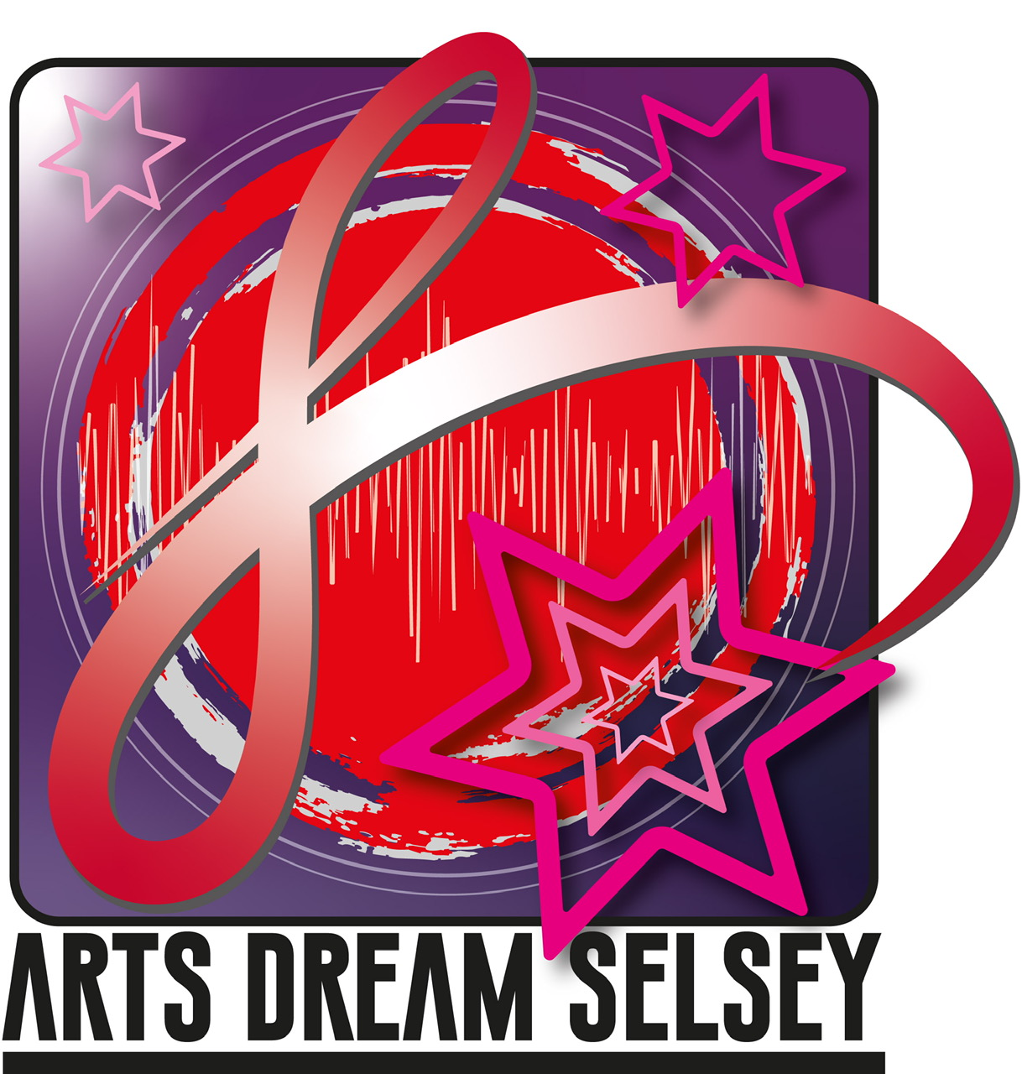
Arts Dream Selsey (ADS ) Covid statement

Arts and culture can illuminate our inner lives and enrich our emotional world and have a wider more measurable impact on our economy, health and wellbeing. ADS is keen on welcoming our users back to restart activities. We know this has been a difficult time for everyone but we are keen to continue with creative live indoor activities and events in line with Government Guidelines.

Statement from ADS:

ADS is hoping to start activities from September 2020 and to pilot art drama, and some limited musical activities. Our aim is to keep all our users, audiences, performers and crew as safe as possible and to limit any possible chance of transmission of the virus.
- We will take account of the necessary guidance from GOV.UK on working safely in the arts, and for guidance for the safe use of multi -purpose community facilities.
- At this time no refreshment, drinks etc will be offered for sale, but users can bring their own individual refreshments.

What you can expect from us :

- Comprehensive Covid Risk Assessments for all activities. These will be published on our website and on our Face Book page
- Specific protocols in place regarding Front of House Procedures for users and staff
- Specific rehearsal strategies in place to minimise transmission and comply with social distancing
- An extensive cleaning regime in place for all activities at a variety of different venues
- New guidance on how to obtain tickets for events, to comply with social distancing and the specific requirements of different venues.
- Volunteers and our trustees trained to be effective in the delivery of Health and Safety requirements
- Volunteers to wear PPE as appropriate
- Compliance with the Risk Assessments of different venues.

What we expect from our users:

- Not to attend any classes or performances if you are feeling unwell,or have any Covid symptoms. At the start of workshops or performances your temperature will be taken, and if you have a high temperature you will be asked to leave
- To use the hand sanitizer that is provided
- To comply with the social distancing guidelines and other signage around the venue
- To wear masks during classes and performances
- To follow floor markings where necessary
- To allow us to keep your contact details to track and trace if necessary

Arts Dream Selsey (ADS )Covid Risk Assessment for all performance events:

Introduction:

COVID-19 is a disease which is caused by the SARS-CoV-2 virus, which can be passed via respiratory secretions (i.e. saliva) and faeces, and which can successfully live for up to 2 to 3 days on certain
surfaces. COVID-19 is an “enveloped” virus, meaning that it is surrounded by a protective layer of fats and proteins.
COVID-19 can be transferred via hands from one surface to another. By touching a surface which has traces of COVID-19 on it, and then touching your face or eyes, you may become infected with COVID-19.
Soap and hand sanitiser are effective at denaturing the fats and proteins surrounding the virus, and therefore good ways to kill the virus.
COVID-19 can live on some common household surfaces for up to 3 days. Information and
knowledge is evolving all the time. Currently it is thought that the virus can live for up to:
● 2-3 hours in the air
● Up to 4 hours on copper
● Up to 24 hours on cardboard, glass and metal.
● Up to 2 or 3 days on plastic and stainless steel.

General Principles:

This General risk assessment is developed in conjunction with other ADS risk assessments that are specific to a particular named performance or event and deals with the principles and process in regard to providing a safe environment for performers and audiences.
It can be applied to a number of venues, although we acknowledge that some venues, and community spaces will need for example additional cleaning, additional space arrangements, and a more robust adherence to rehearsal. ADS will put in place any measures or adjustments we see fit to comply with the necessary guidance.

The following Risk Assessment has been complied with details, information and suggestions from:
- Gov.UK- Guidance and support for the safe use of multi -purpose community facilities
- Gov.UK- Working safely during coronavirus. – specifics on performing arts
- Arts Council England. – advise to venues.
- DCMS – Covid Guidelines
- Arts Professional – Covid toolkit
- Nesta- Creativity and Culture
- PASC-The Professional Association of self -Catering, protocols for Cleaning
- CDC Covid advise to businesses.

ARTS DREAM SELSEY COVID RISK ASSESSMENT

User Group:  Arts Dream Selsey .................................. | Nature of performance:  ...Theatrical presentation .................................. | Venue:  St PETER’S HALL SELSEY
Risk assessment completed by:-  ...Chris Butler .................................. | Contact phone no:  ...01243606740.................................. | Email address:  chrisbutlerselsey@hotmail.co.uk...................................

RISK ASSESSMENT KEY
Severity | Likelihood | Risk rating
What is the potential level of injury to persons and / or damage to property caused by the hazard? | How likely is the hazard to happen? | Risk rating = Severity x Likelihood
- Slight  - Minor  - Moderate  - Major  - Severe | - Highly unlikely  - Not very likely  - Possible  - Likely  - Very likely

- To ensure preparation procedures for performances limits the possibility of transmission
Description of activity / as- sociated risks | Who could be affected | Severity 1 to 5 | Likelihood 1 to 5 | Risk rating | Control measures  / action plan
- Lack of robust approach to preparation to front of house requirements may result in risk of transmission |  | 1 | 1 | 1 | - ADS to install screens on front of house table  - ADS to install necessary signage wherever necessary  - All procedures to be articulated on the ADS website, our face book page and through our mailing list  - The number of front of house staff will be limited and staff will wear masks and visas  - Everyone to use hand sanitizer before and after they enter and leave the venue  - Temperature of all audience members, staff and performers will be taken  Anyone with a temperature will be asked to leave  - Track and trace lists will be kept , to include, name and phone number of all audience members, performers and crew  - Tickets will be sold through one venue only. Tickets will be shown but not ripped or collected.  - ADS will be provide a contactless payment system for the purchase of tickets  - Individuals will be seated as family groups, individuals or as a support bubble  - There will be an on -line programme but no paper programme  - All audience members to wear masks during performances  - Where appropriate there will be a live introduction to the Production  To note that in the short term there will be no selling of refreshments

- To ensure social distancing is possible by limiting the number of people before, after and during live performances, to minimize transmission
Description of activity / as- sociated risks | Who could be affected |  | Severity 1 to 5 |  | Likelihood 1 to 5 |  | Risk rating |  | Control measures  / action plan
- Too many audience numbers increase risk  - Large numbers of performers increase risk  - complex technical set up with too many technical staff increases risk  - Length of show causes too much use of toilet facilities  staff increases risk | Audience, cast and crew |  | 1 |  | 1 |  | 1 |  | ADS has agreed that in the short term we will:  - Limit audience numbers to 30 for all venues, ensuring social distancing  - Limit number of performers for performances from October 2020- February 2020 to ensure social distancing  - Limit lighting and sound requirements to essential requirements only.  - Provide a clear communication strategy through the use of signage for leaving the building  - Ushers to be used to navigate audiences in and out of the space  - Work with a small group of technical staff  - To limit the use of toilets as much as possible shows will be for an hour only  - All audience members to wear masks
- To ensure cleanliness of venue, and all equipment limits the possibility of transmission
Description of activity / as- sociated risks |  | Who could be affected |  | Severity 1 to 5 |  | Likelihood 1 to 5 |  | Risk rating |  | Control measures  / action plan
- Lack of insufficient cleaning puts  people in undue risk of transmission |  | Audiences, cast and crew |  | 1 |  | 1 |  | 1 |  | - ADS to purchase cleaning products, to include, spray virucidal disinfectant, gloves, protective clothing, cloths and masks, soap , hand sanitizer and paper towels  - More time be given between and after performances to ensure deep cleaning  - All cleaners ( volunteers ) to wear protective clothing, masks, disposable gloves.  - Thorough cleaning will include wiping down of surfaces, tables, chairs, door handles and technical equipment, to include for example lanterns, sound equipment, and musical instruments with appropriate disinfectant  - Where appropriate the floor to be washed  - All windows to be opened during cleaning and the room to be well ventilated  - All cleaners advised to wash hands thoroughly after cleaning.  - ADS to instigate a compliance sheet to indicate what has been cleaned in preparation for the next group, event, or performance.

- To ensure the procedures for rehearsal and performers by actors limits the risk of infection.
Description of activity / as- sociated risks | Who could be affected | Severity 1 to 5 | Likelihood 1 to 5 | Risk rating | Control measures  / action plan
- Failure to adhere to relevant  Rehearsal and performance protocols puts undue risk on performers, crew and technical support | Cast, crew and all  Performers | 1 | 1 | 1 | - In the short- term performers will be limited to 8 per show  - To limit rehearsal time and scheduling, performances will mainly be readings of scrips, with some sound effects  - Where possible family groups will take on specific roles such as acting and  Technical support
- Rehearsal will be in a large well- ventilated room, all socially distanced, and will be time limited.
- Most requirements for technical support will be discussed on- line and communicated briefly through a limited rehearsal period.
- There will be no audience interaction from performers
- The time on set and fit ups for performances will be limited and where possible this will be achieved by a family group
- In the short term there will be no use of back- stage. If a costume is necessary performers will come to the performance in costume and make up, and bring with them any necessary refreshments.
- After each show the cast will be asked to leave to accommodate a deep clean in preparation for the next show
- All personal props will be deep cleaned by the performer
- All other props, equipment and musical instruments will be deep cleaned after each show

Notes:
- This is a short- term risk assessment and will be operated from October to December 2020
- During the operation of a performance the risk assessment will be carefully monitored, and any necessary practical changes made
- Once operational we will be able to access the severity and likelihood of the risk and update the Risk rating

Chris Butler updated October 22nd

